Email account setup on the new server
Email account setup for Microsoft Outlook

This manual based on Polish version of Microsoft Outlook. Therefore some of those commands are translated on English and can be different in English version of MS Outlook.
- open Microsoft Outlook
- expand bookmark Narzędzia (tools) in main menu and click Opcje (options)
- in the Opcje (options) click on bookmark Ustawienia poczty (mail settings) then click button Konta e-mail…(mail account…)
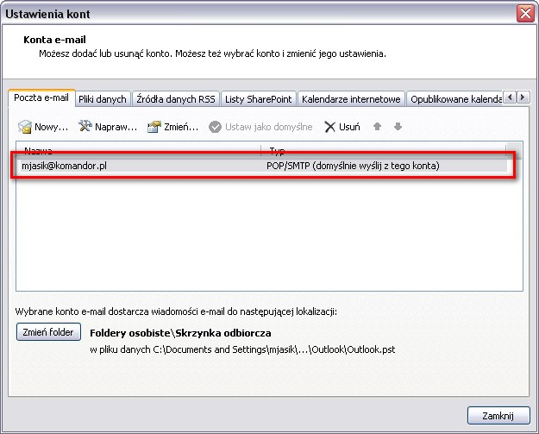
- In the Ustawienia kont (Account settings) double click on account (for which you want to change settings) on the list, the window Zmienianie konta e-mail (Changing account mail) appears
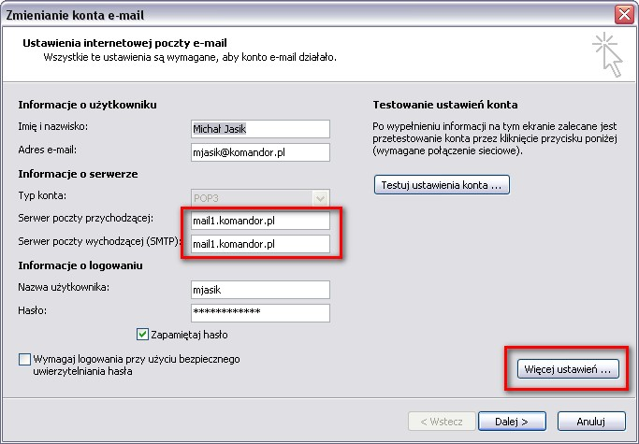
- In the Zmienianie konta e-mail (Changing account mail):
  - Serwer poczty przychodzącej (incoming mail server) enter mail1.komandor.pl
  - Serwer poczty wychodzącej (SMTP) (outgoing mail server) enter mail1.komandor.pl
- Click button więcej ustawień (more settings), the Ustawienia internetowej poczty e-mail (setup an Internet mail) appears
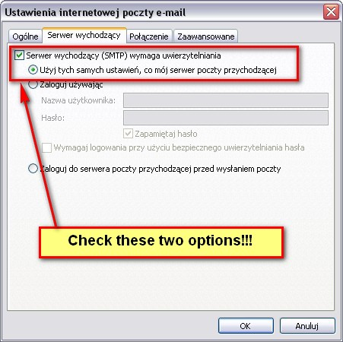
- In the Ustawienia internetowej poczty e-mail (setup an Internet mail) go to bookmark Serwer wychodzący (outgoing server) and next:

  - check Serwer wychodzący (SMTP) wymaga uwierzytelnienia (outgoing server (SMTP) requires authentication)
  - check Użyj tych samych ustawień, co mój serwer poczty przychodzącej (use the same settings as my incoming mail server)

- Go to bookmark Zaawansowane (advanced) and fill the field:
  - Serwer przychodzący (incoming server)
    - 995 for POP3
    - 993 for IMAP
  - check Ten serwer wymaga zaszyfrowanego połączenia (SSL) (This server requires an encrypted connection (SSL) and select the type of encryption SSL
  - Serwer wychodzący (outgoing Server) (SMTP) enter 465

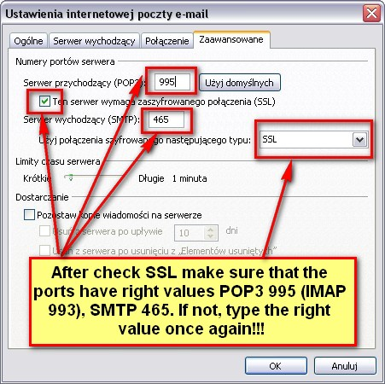
  - Confirm changes by click OK.
  - In the Zmienianie konta e-mail (changing mail account) click button Testuj ustawienia konta (test account settings)
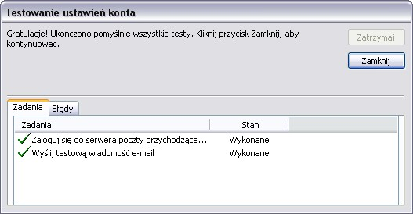
- If the test is successful click Zamknij (close) and In the Zmienianie konta e-mail (changing account mail) click button Dalej (next). You should see the window:
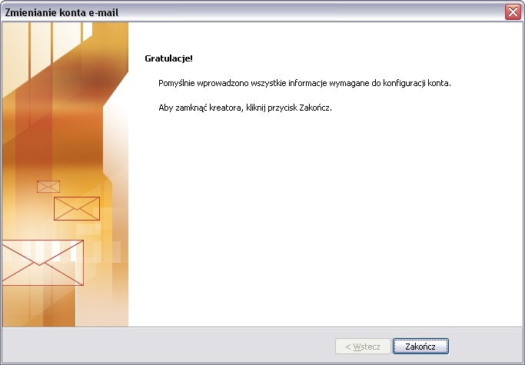
If you finished your account setup and your e-mail doesn't works please check if your mail works on website: https://webmail.komandor.pl.
If your mail still doesn’t work, please contact with your Administrator.
Additional information
- You can also access to your email by:
  - Log on https://webmail.komandor.pl – TLS option must be enabled in browser settings
  - Mobile phone https://help.komandor.pl/help/imap_tel/imap_tel.html
  - Mobile phone - aplication Poczta https://webmail.komandor.pl/horde/imp/redirect.php?autologin=&url=%2Fhorde%2Fmimp%2Findex.php webmail.komandor.pl and selsct mimp option.
In case of any problems go to our help site https://help.komandor.pl or contact with your Administrator.

