Email account setup on the new server
Email account setup for Outlook Express

- Open Microsoft Outlook Express
- If you don’t have your account click Create an e-mail account…
- In the Internet Connection Wizard type name and click Next
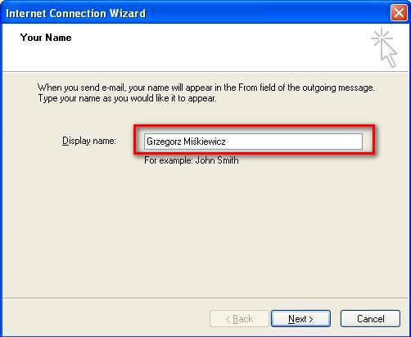
- Next step enter E-mail address
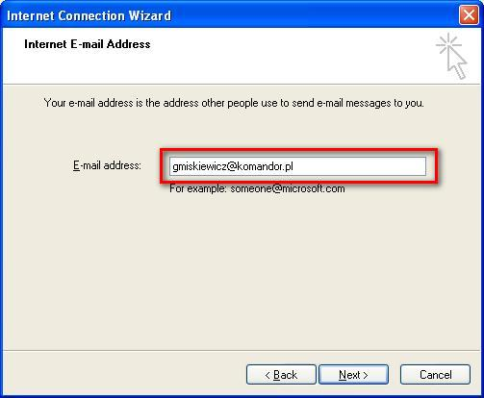
- Click Next
Settings for IMAP
- Incoming mail: mail1.komandor.pl
- Outgoing mail: mail1.komandor.pl

- Click Next
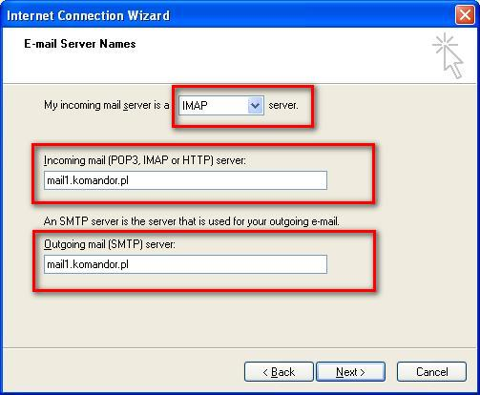
- Enter Account name and Password,
- Click Next
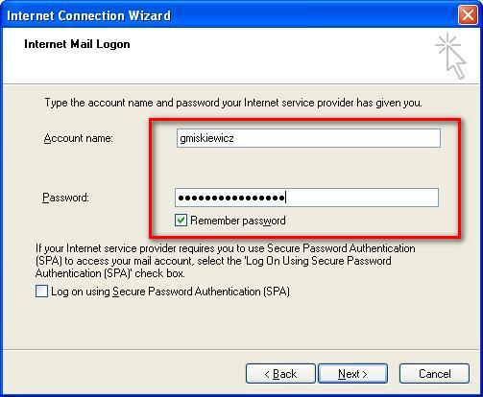
- In the main menu click bookmark Tools and choose Accounts from the list.

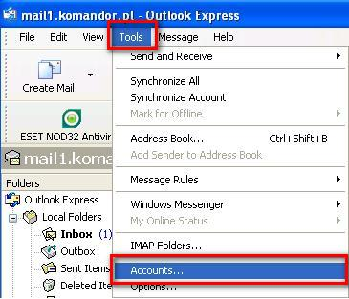

- In the Internet Accounts double click on account on the list

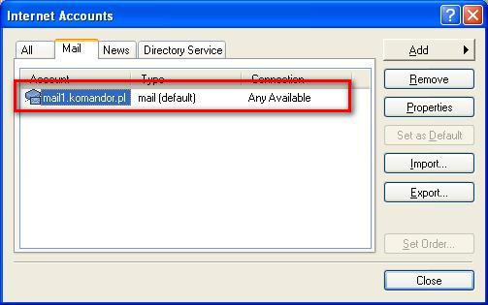
- In the mail1.komandor.pl Properties go to Servers bookmark and check: My server requires authentication
- Click OK.
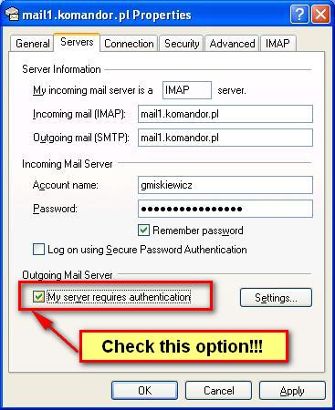

- Go to bookmark Advanced and enter:
  - Outgoing mail (SMTP): 465
  - This Server requires a secure connection (SSL)
  - Incoming mail (IMAP): 993
  - This server requires a secure connection(SSL)
- Click OK.

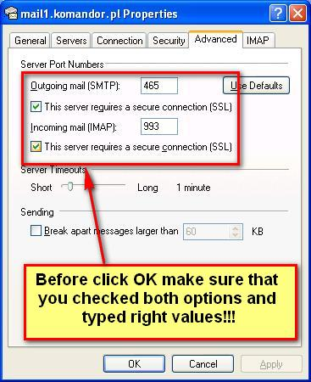
Settings for POP3
- Incoming mail: mail1.komandor.pl
- Outgoing mail: mail1.komandor.pl
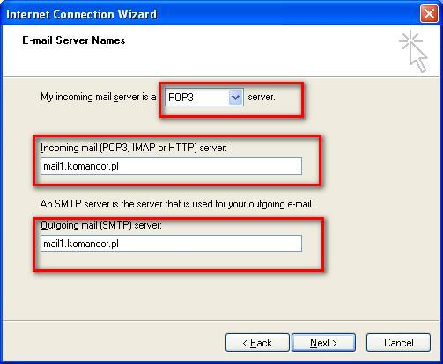
- Click Next
- Enter Account name and Password,
- Click Next
- Click Finish

- In the main menu click bookmark Tools and choose Accounts from the list.
- In the Internet Accounts double click on account on the list
- In the mail1.komandor.pl Properties go to Servers bookmark and check: My server requires authentication

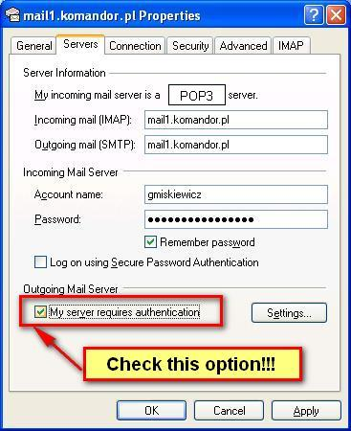
- Click OK.
- Go to bookmark Advanced and enter:
  - Outgoing mail (SMTP): 465
  - This Server requires a secure connection (SSL)
  - Incoming mail (IMAP): 995
  - This server requires a secure connection(SSL)
- Click OK

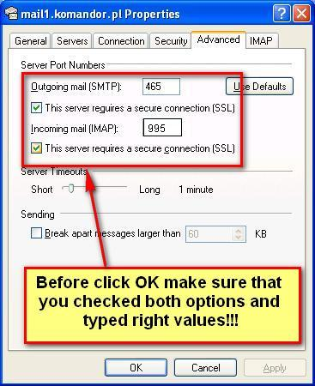

If you finished your account setup and your e-mail doesn't works please check if your mail works on website: https://webmail.komandor.pl.
If your mail still doesn’t work, please contact with your Administrator.
Additional information
- You can also access to your email by:
  - Log on https://webmail.komandor.pl – TLS option must be enabled in browser settings
  - Mobile phone https://help.komandor.pl/help/imap_tel/imap_tel.html
  - Mobile phone - aplication Poczta https://webmail.komandor.pl/horde/imp/redirect.php?autologin=&url=%2Fhorde%2Fmimp%2Findex.php webmail.komandor.pl and selsct mimp option.
In case of any problems go to our help site https://help.komandor.pl or contact with your Administrator.

